**Simple Legal**

Created a Package in dev instance to load data into Interface table and Interface to Base table.

Package Name: XXX_AP_RESTAPI_INVOICE_PKG

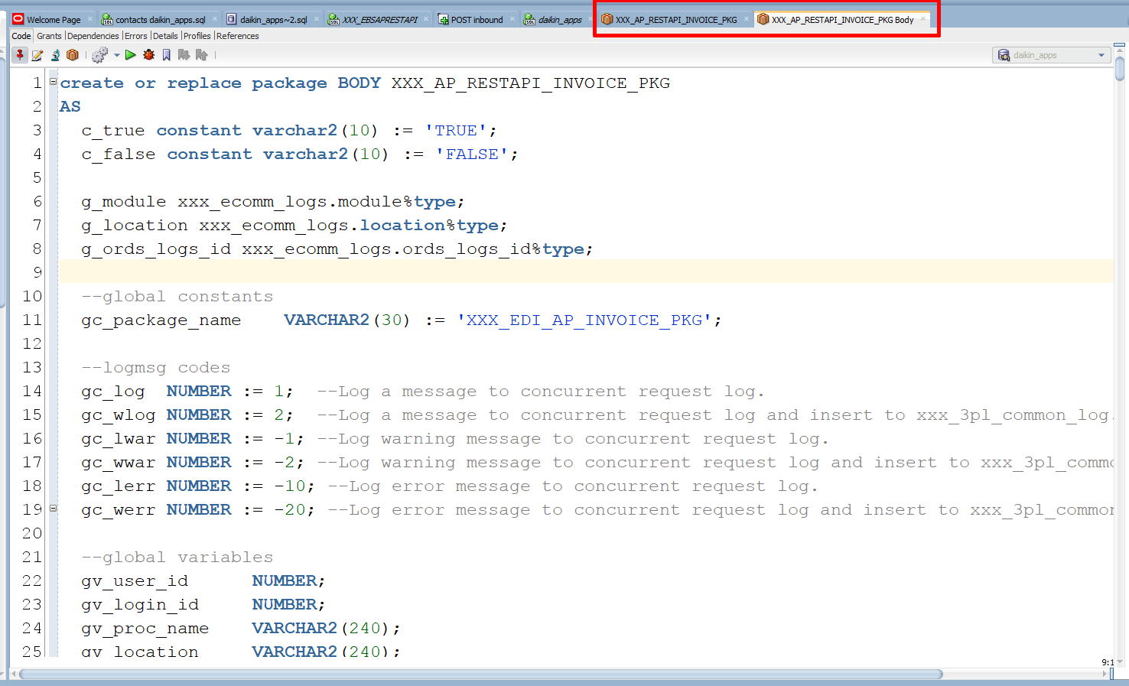

**Step 1:**

Create a User in SYS.

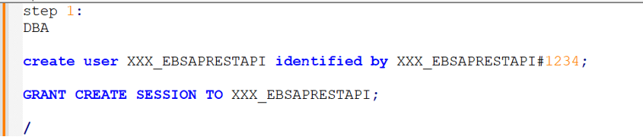

Step 2:

Log in and connect to that USER

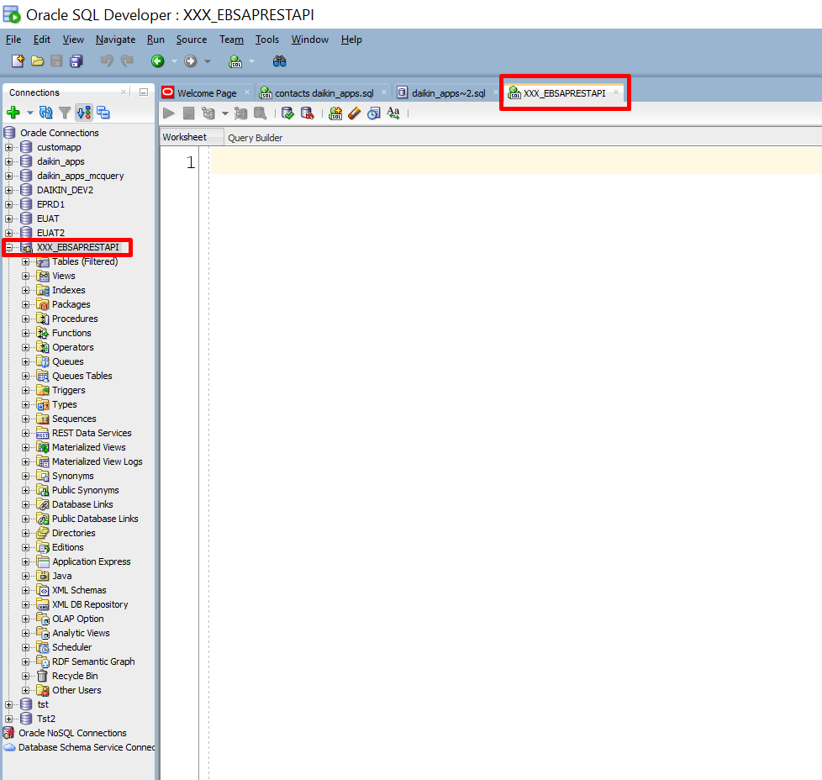

Step 3:

Establish a Session with the user defined.

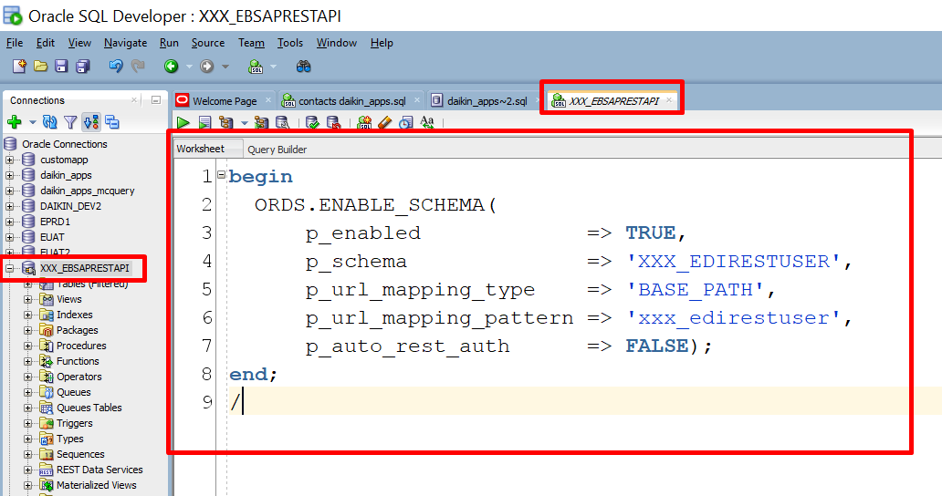

Step 4:

Create a Module

Module Name: daikin.ebs.ap.rest

URI Prefix: /ebs/ap/rest

Enable Publish – To make it public API

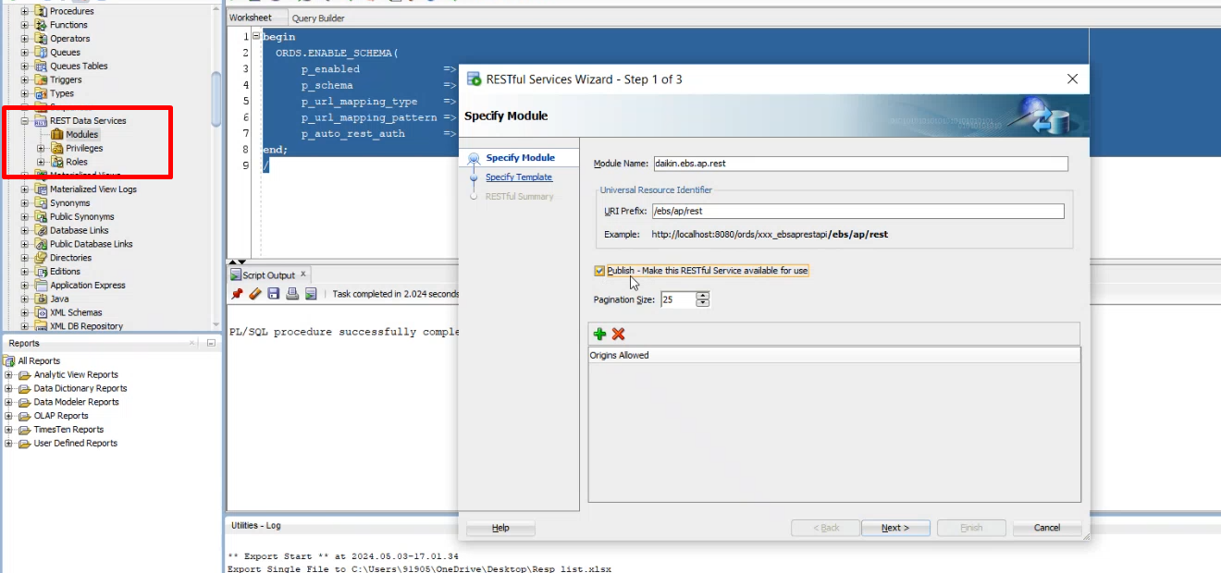

Click on Next

Create a Template – Template is a Mandatory

URI pattern: **Inbound**

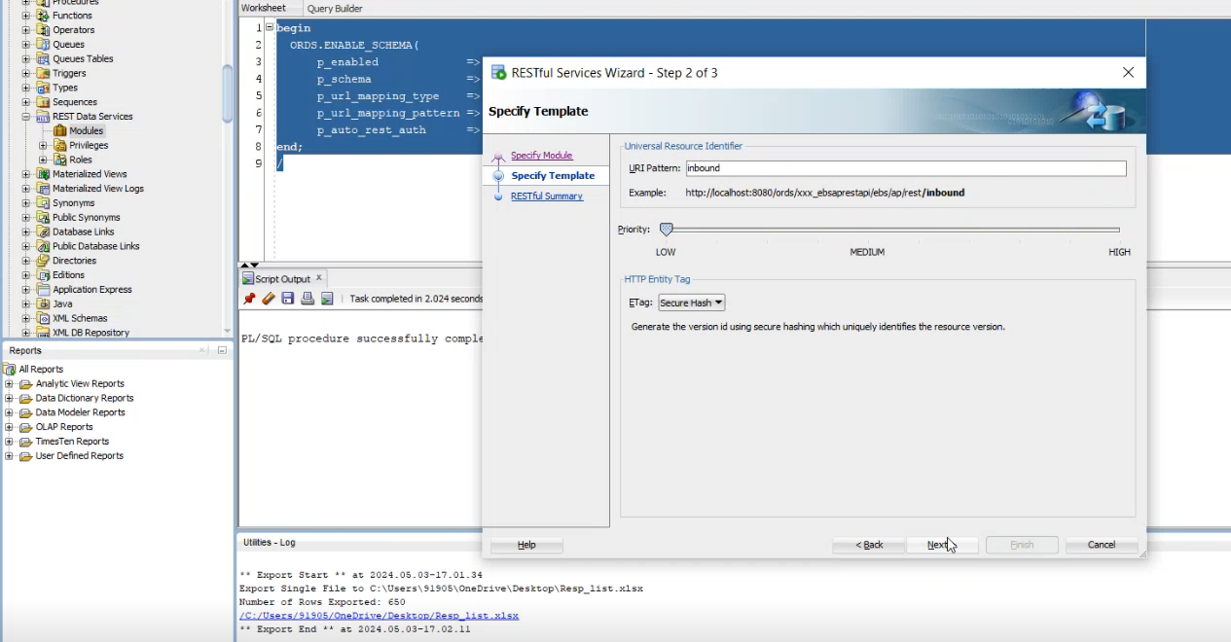

Click on Next

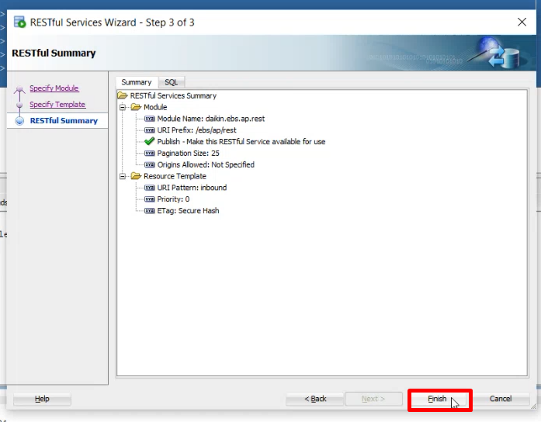

Click on Finish

Created a Module under Rest Data Services.

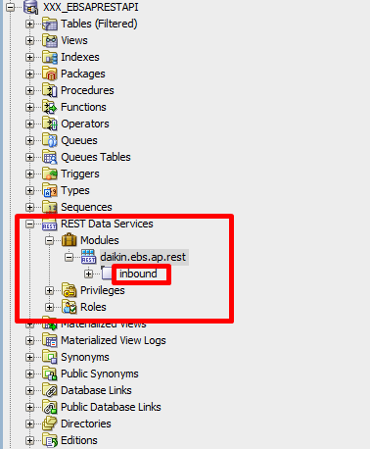

Step 5:

Creating a Handler:

For a template we have to create a service. Service means a Creating a Handler.

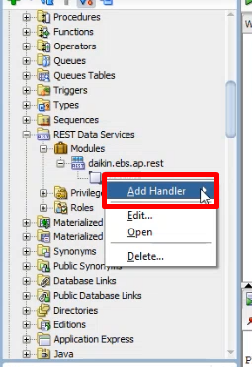

There are 4 types of Handlers, we are creating POST method

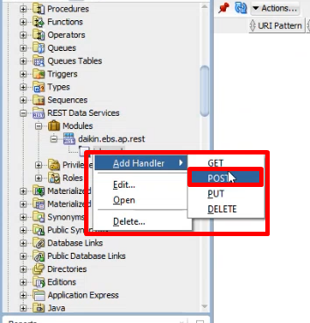

Click on POST

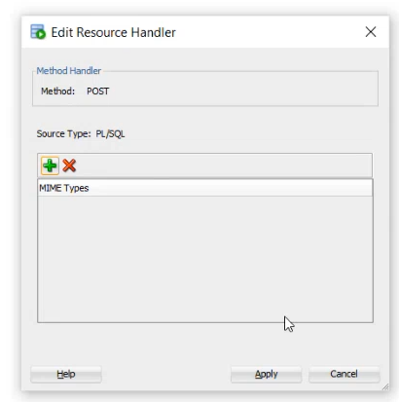

Click on Apply

In POST we write a Code

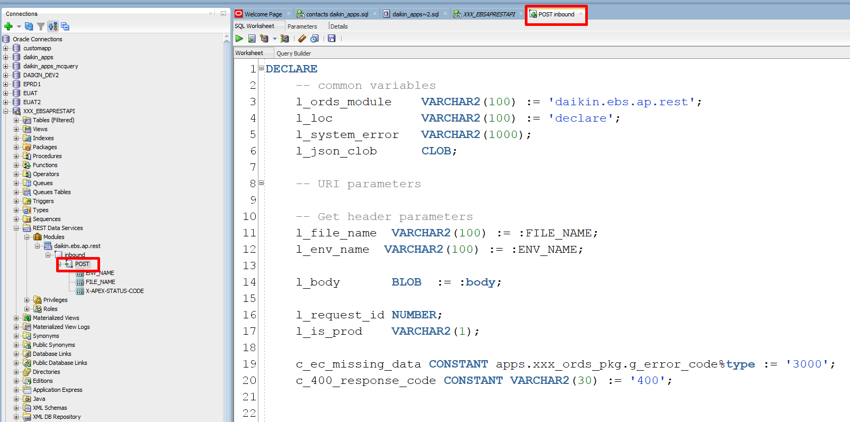

Click on Parameters and Add parameters.

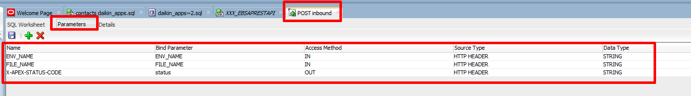

Step 6:

Log Into the dev instance and give grants to specific Packages.

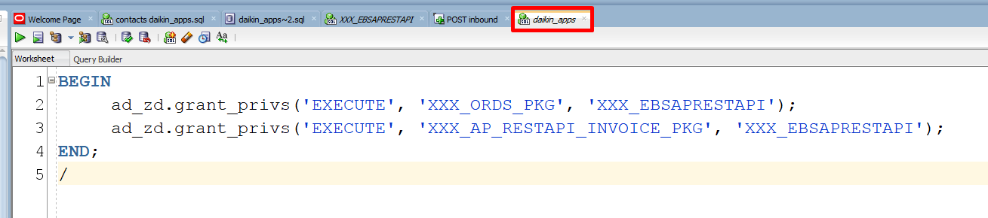

Step 7:

ORDS security:

Enable ORDS security roles in the created Rest API service XXX_EBSAPRESTAPI

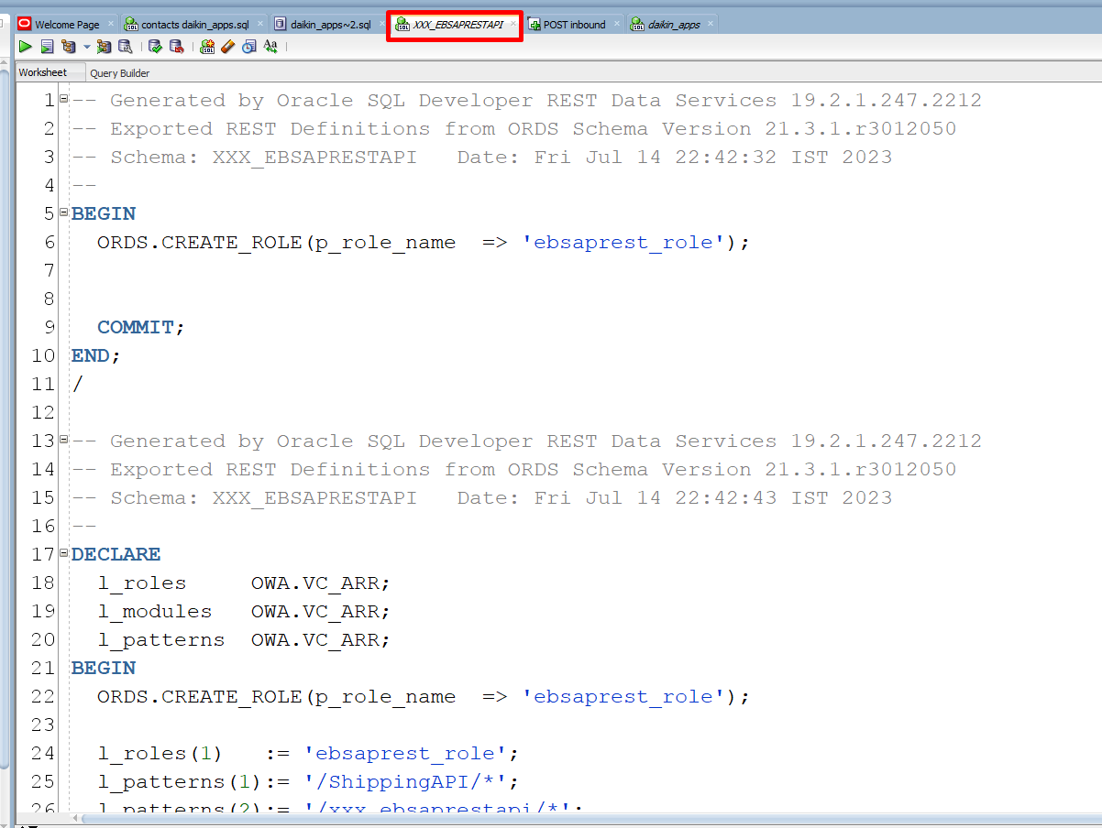

Roles are created in REST API services

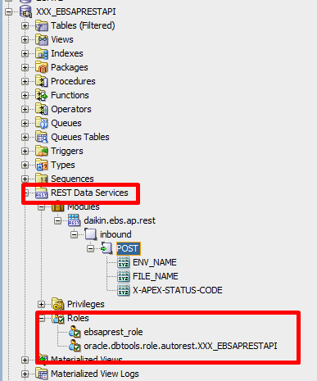

Create USER XXX_EBSAPRESTAPI in Dev instance – To avoid error with the USER

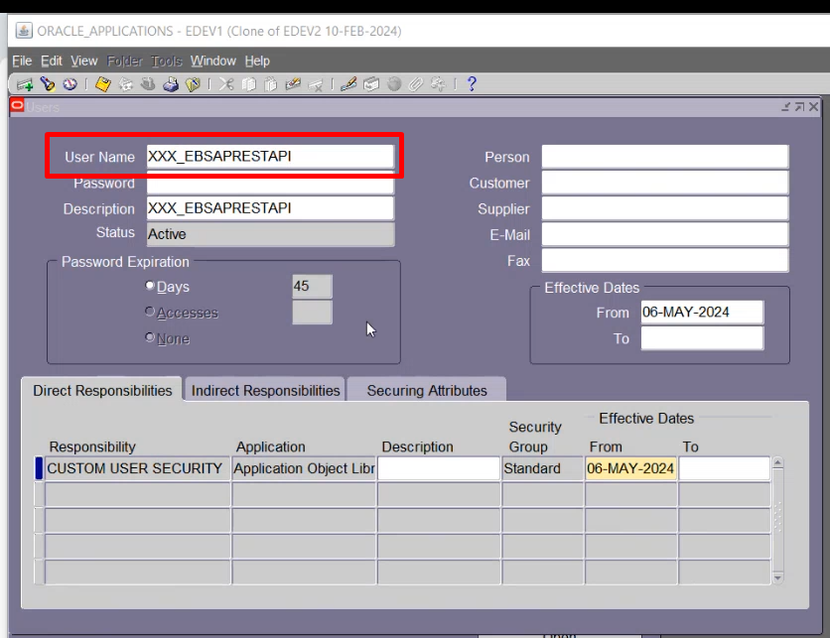

Step 8:

Test in the POST man:

Invoice importing to Oracle.

If new Invoice it will be successfully imported to Oracle.

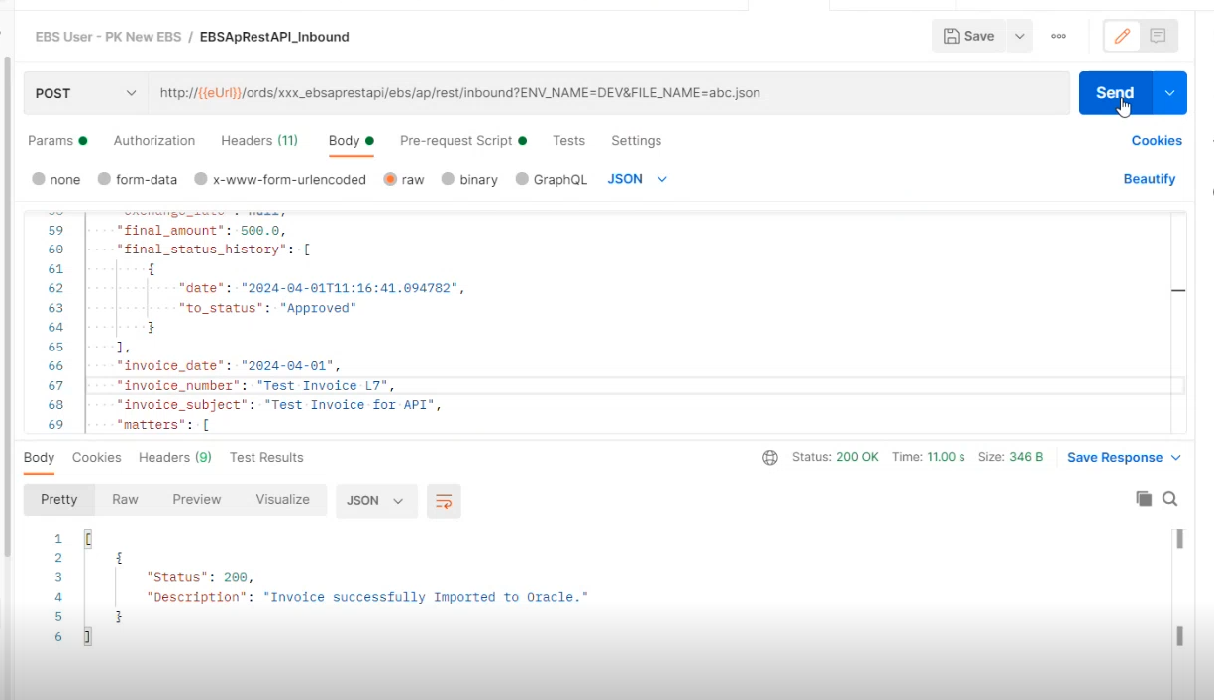

Invoice Created in Oracle application.

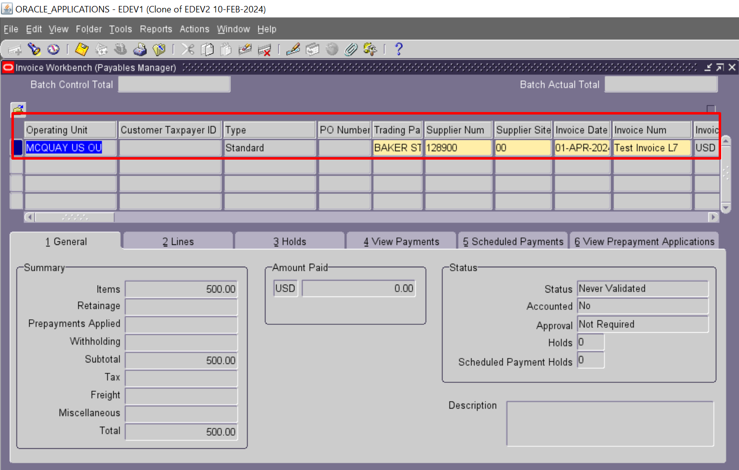

If Invoice already exits it will show an error message like below screenshot.

